**Clinical outcomes of orthologous heart transplant after implantation of left ventricular assist devices (LVAD) in the same hospitalization**

**Clinical outcomes of orthologous heart transplant after implantation of left ventricular assist devices (LVAD) comparing time to transplant and the use of invasive hemodynamic monitoring: an NIS study**

**Running Title: OHT timing and characteristics after LVAD placement**

David Ouyang, MD1,2, Gunsagar Gulati1,2, Dipanjan Banerjee, MD2

1. These authors contributed equally to this work. 2. Stanford University School of Medicine, Stanford, CA 94305, USA.

**Address for Correspondence:**David Ouyang, MD  
300 Pasteur Drive, L154  
Stanford, CA 94305  
Telephone: 832-495-1605  
Fax: **877-991-6506  
Email: Ouyangd@stanford.edu**

**Journal Subject Code:**

**Abstract**

**Background -** The optimal timing for orthologous heart transplant (OHT) after the implantation of left ventricular assist devices (LVAD) is unknown. The need for clinical stability and time to recover from major surgery is balanced by the risk of LVAD complications and the formation of adhesions and scarring in determining the optimal time for OHT after LVAD and there exists significant inter-center variation in the timing of OHT and use of invasive hemodynamic monitoring.

**Methods and Results** - With the Nationwide Inpatient Sample (NIS) from 1998 to 2011, we identified 2200 patients 18 years of age or greater who underwent implantation of a LVAD and for which day of procedures was available. On average, patients underwent first LVAD placement on day 9.4 of hospitalization and started invasive hemodynamic monitoring 7.2 days prior to LVAD placement. Patients who had invasive hemodynamic monitoring (n = 491, 22.32%) were not significantly different with respect to age (,gender ratio, # of concomitant diagnoses**), however waited longer for LVAD implantation (13.4 days vs. 8.5 days, p < 0.XXX) but had less in-hospital mortality (20.0% vs. 28.5%, p <0.XXX). 164 (7.5%) patients also underwent OHT during the same hospitalization, which occurred 32 days (IQR 7.75 - 66 days) after LVAD implantation. Of patients who underwent OHT, increased in-hospital mortality was identified in patients who underwent transplantation within 7 days of LVAD implantation compared to patients who underwent transplant after 8 days (26.8% vs. 12.2%, p = 0.0483).There was no statistically significant difference in patient demographics with regards to age, sex, race, household income, or number of comorbid diagnoses. Patients who waited longer after LVAD implantation for OHT had longer hospital stays (39.3 ± 33.2 days for the first quartile, 48.87 ± 25.6days for the second quartile, 85.8 ± 40.1 days for the third quartile, 151.2 ± 52.6 days for the fourth quartile). Compared to patients who underwent LVAD implantation but did not undergo OHT, patients who underwent late OHT after LVAD had decreased mortality (12.2% vs. 27.3% p < 0.001). Patients who underwent early transplant after LVAD did not show a similar mortality benefit (26.8% vs. 27.3%, p = 0.946).

**Conclusions** - Mortality is increased for patients who undergo heart transplant within 1 week of LVAD implantation compared to patients who did not receive OHT during the same hospitalization, patients who undergo OHT later during the same hospitalization, and patients who required secondary LVAD placement. Patients who undergo invasive hemodynamic monitoring appear to have better outcomes, however there can be selection bias as these patients could have also been waiting for OHT.

**Introduction**

Heart failure (HF) affects an estimated 5.8 million people in the United States and contributes to over 300,000 deaths every year1,2. It is the most common cause of hospital admission and readmission in people aged >65 years, annually accounting for over 2.4 million hospitalizations2,3 and $39 billion in healthcare costs1,4. Although most patients respond favorably to standard medical treatment, a considerable number of patients progress to end-stage heart failure refractory to medical therapy5. Currently, orthostatic heart transplant (OHT) is the gold standard therapy for these patients6,7,8, however the number of donor hearts available for transplantation are far fewer than the number of patients with end-stage heart failure. Therefore, these patients are placed on mechanical circulatory supports like the Left Ventricular Assist Device (LVAD) as either a temporary bridge to transplantation (BTT) or permanent destination therapy (DT).

With the growing elderly population and improved medical treatment of HF, the proportion of end-stage heart failure patients in the United States is steadily rising and LVADs are becoming increasingly important in their care and management5. The REMATCH trial in 2001 showed significant mortality reductions in patients placed on a pulsatile-flow LVAD compared to standard medical treatment9. Several subsequent studies since confirmed the survival benefit of both the older pulsatile and newer continuous-flow LVADs10-13. Patients bridged to OHT with a LVAD achieve equal survival rates as patients who undergo direct heart transplant14. Although a comparatively less effective option to BTT, patients placed on LVADs as destination therapy experience lower mortalities compared to patients on standard medical treatment9,15.

Although BTT, DT, and in-hospital LVADs have substantially reduced mortality in end-stage heart failure patients, the absolute mortality rates still remain high. A large portion of this mortality is attributable to complications and other occurrences during the patient’s stay in the hospital15. In-hospital mortality rates as high as 27% have been reported in patients after LVAD surgery15. As the rate of LVAD implantation in the United States increases and readmission and in-hospital mortality rates, although decreasing, remain at a high level19-22, effective recommendations on the in-hospital management of LVAD implantation are essential.

Past studies on the appropriate use and outcomes of LVADs have been limited to institutional experience and case series of select populations. While such descriptive investigations are useful, they are often limited by small sample size and significant baseline variation between institutions and comparison groups. Therefore, here we use the National Inpatient Sample, the largest national database of hospitalizations in the United States with data from over 36 million hospitalizations, to assess the optimal management of patients before, during, and after LVAD implantation in the hospital. In particular, we report trends in mortality by duration of hemodynamic monitoring, timing of LVAD implantation, and wait time for same-admission OHT. We also report trends in LVAD mortality by age, gender, and year and present demographic characteristics of documented LVAD recipients from 1998 to 2011.

**Methods**

**Data Source**

The Nationwide Inpatient Sample (NIS), from the Healthcare Cost and Utilization Project, Agency for Healthcare Research and Quality, is the largest database of all-payer inpatient discharge information, sampling approximately 20% of all non-federal US hospitals and including approximately 9 million hospital admissions each year. It contains discharge data from over 5000 hospitals located across 45 states, of which approximately 1,200 hospitals are sampled each year to create a statified sample of United States hospitals. Each NIS entry includes all diagnosis and procedure codes of activity during the patient’s hospitalization at the time of discharge, as well as patient demographics, hospital characteristics, and short-term complications of the hospitalization.

**Study design and Cohorts**

This was a retrospective cross-sectional study using the Nationwide Inpatient Sample (NIS) between 1988 and 2011. We identified all hospitalizations from 1988 to 2011 of patients 18 years of age or greater that underwent placement of a left ventricular assist device and for which the hospital day of each procedure was available. Procedures during the hospitalization in addition to LVAD placement, including orthologous heart transplant, extracorporeal membrane oxygenation, intubation, hemodialysis, invasive hemodynamic monitoring, cardiac catheterization, and reoperation were identified by associated ICD9 codes. Additionally, hospital mortality and perioperative morbidity such as post-operative infections, cardiopulmonary complications, and hemorrhagic complications were identified.

**Statistical Analysis**

Python 2.7 (Python Software Foundation, www.python.org) and R 2.13 (R Foundation, www.r-project.org) were used for statistical analysis.

**Results**

**Patient characteristics and LVAD implantations**

The total study sample consisted of 2200 patients who received an LVAD implantation in a US hospital between 1998 and 2011. Total in-hospital mortality rate was 26.8%. The mean age of all 2200 patients was 53.4 years (SD = 13.7, range = 18-92 years). Age-stratified analysis showed an increase in in-hospital mortality from LVAD implantation with age (r^2 = XXX, trend p value <****). Additionally, more male patients received LVAD implantations than female patients [n = 1659 (75.4%) vs. n = 541 (24.6%), p = XXXXX] and in-hospital mortality rates were higher among females than males (32.0% vs 25.1%, p = XXXXX). Whites comprised the largest proportion of LVAD recipients from 1998-2011 [n = 1274 (57.9%), p = XXXXX] followed by Blacks [n = 352 (16.0%), p = XXXXX]. In-hospital mortality rates were highest in Asian/Pacific Islanders (45.1%, p= XXXXX) and lowest in Blacks (18.2%, p=XXXXX).

The most common comorbidities observed in patients were cardiac dysrhythmias [n = 1372 (62.4%), p=XXXX], respiratory failure [n = 563 (25.6%), p=XXXX], diabetes [n = 392 (17.8%), p=XXXX], disorders of lipoid metabolism [n = 310 (14.1%), p = XXXXX], hypertension [n = 301 (13.7%), p = XXXXX], history of or current use of tobacco [n = 144 (6.5%), p = XXXXX], and BMI ≥ 30 kg/m2 [n = 96 (4.4%), p = XXXXX]. In-hospital mortality was particularly high among patients with respiratory heart failure (36.8%, p=XXXX), hypertension (30.9%, p=XXXX), and cardiac dysrhythmias (25.7%, p=XXXX).

Of the 2200 patients, 2130 received only one LVAD, 67 received two LVADs, and 3 received three LVADs during the same admission. Mortality comparison revealed higher mortality rates in patients who received two LVADs (56.7%, p = XXX) and three LVADs (100.0%, p = XXX) compared to patients who received only one LVAD (25.8%, p = XXX) during their hospital stay. Most LVAD implantations were performed in large [n = 1931 (87.8%), p = XXXXX] teaching hospitals [n = 2033 (92.4%), p = XXXXX] in urban communities [n = 2181 (99.1%), p = XXXXX]. Mortality rates were higher in patients who received LVAD implantations in small (50.0%, p = XXXX) non-teaching hospitals (37.6%, p=XXXX) in rural communities (52.9%, p=XXXX). Temporal trends in LVAD showed an increase in the number of implantations from 1998 to 2011 (r^2 =XXX, trend p-value < ****). Overall in-hospital mortality remained consistently high between 1998 and 2006 (r^ 2 = XXX, trend p-value = 00000) and linearly decreased between 2007 and 2011 (r^2 = XXXX, trend p value = XXXX). Taken together, the demographics and trends observed in our study sample are consistent with existing data on LVAD implantation in the US.

**Duration of Hemodynamic Monitoring Prior to LVAD Implantation**

Effective hemodynamic monitoring of end-stage heart failure patients prior to LVAD implantation may reduce post-procedural complications and improve survival outcomes. 403 patients with Swan-Ganz catheterization prior to LVAD implantation were compared to 1797 patients without pre-procedural Swan-Ganz. Demographic comparison between Swan-Ganz+ and Swan-Ganz- groups revealed no significant differences in age (p>0.05), gender (p>0.05), race (p>0.05), income (p>0.05), comorbidities (p>0.05), year of hospitalization (p>0.05), or hospital type (p>0.05). However, in-hospital mortality rates were significantly lower in patients who received Swan-Ganz prior to LVAD implantation than patients who did not (19.1% vs 28.5%, p<XXX). To test whether this mortality difference could be explained by the higher priority status for heart transplant assigned to patients with Swan-Ganz, we compared the rate of OHTs between the two groups. No significant difference in the rate of OHTs were observed between Swan-Ganz+ and Swan-Ganz- groups (5.5% vs 7.7%, p>XXXX).

We next wanted to see whether the duration of pre-procedural hemodynamic monitoring affects in-hospital outcomes of LVAD implantation. The median duration of Swan-Ganz catheterization in the 403 patients was 6 days (IQR 2-12 days). Patients who were kept on Swan-Ganz longer had longer hospital stays (32.0 ± 42.0 days for the first quartile, 37.6 ± 27.4 days for the second quartile, 39.9 ± 27.0 days for the third quartile, 63.7 ± 41.6 days for the fourth quartile). In-hospital mortality rates stepwise decreased with duration of Swan-Ganz catheterization, dropping from 26% mortality in patients catheterized for 1-2 days to 15% mortality in patients catheterized for ≥13 days before LVAD implantation (p<XXX). Compared to patients who underwent LVAD implantation but did not receive Swan-Ganz catheterization, patients who were catheterized for 1-2 days had decreased mortality (15.4% vs. 28.5%, p <XXXX). Patients who underwent Swan-Ganz catheterization for only 1-2 days prior to LVAD implantation did not exhibit a similar mortality benefit (27.2% vs 28.5%, p<XXXX)

**Timing of initial LVAD implantation**

The timing of LVAD implantation after a candidate patient is admitted to the hospital is extremely variable. The median day of initial LVAD implantation from our sample was 6 days after hospital admission with a range of 153 days. Therefore, we asked whether the day of initial LVAD implantation could be associated with trends in mortality in end-stage heart failure patients. The days of initial LVAD implantation for all 2200 patients were divided into quartiles (0-1 days, 2-5 days, 6-12 days, ≥13 days), and mortality rates were determined for each interval. The in-hospital mortality rate from LVAD implantation was highest within the day after admission at 34.9%. Thereafter, mortality decreased to a cumulative rate of 24.3% for all patients who received LVADs after day 2 (p-value <XXXX)

**Wait time for OHT after LVAD implantation**

Orthostatic Heart Transplant (OHT) is the gold-standard therapy for end-stage heart failure patients, but, currently, there are more eligible candidates for OHT than donor hearts available. To account for this shortage, LVADs provide temporary circulatory support for patients while they wait for an OHT. While most LVADs are intended for long-term support, they can also be used for short-term, in-hospital support for same-admission OHT. We assessed outcomes from LVADs by comparing 164 patients who received short-term LVADs with same-admission OHT (st-LVAD OHT+) to 243 patients who received short-term LVADs without same-admission OHT (st-LVAD OHT-) and 1793 patients who received long-term LVADs without same-admission OHT (lt-LVAD OHT-). Short-term LVADs were defined as LVADs removed from the patient before discharge, while long-term LVADs were defined as LVADs not removed before discharge. Demographic comparison between the st-LVAD OHT+, st-LVAD OHT-, and lt-LVAD OHT- groups revealed no significant differences in gender (p>0.05), race (p>0.05), income (p>0.05), comorbidities (p>0.05), year of hospitalization (p>0.05), or hospital type (p>0.05). However, on average, st-LVAD OHT+ patients were younger than st-OHT- and lt-OHT- patients (48.2 ± 13.5 vs. 54.4 ± 12.9 and 55.5 ± 13.3, p <XXX). Comparison of survival outcomes between groups revealed that in-hospital mortality rate was significantly lower in st-LVAD OHT+ than in st-LVAD OHT- and lt-LVAD OHT- (15.9% vs 38.7% and 26.2%, p<XXXX).

We next investigated whether the timing of OHT after LVAD implantation in the st-OHT+ group could influence in-hospital outcomes of end-stage heart failure patients. The median wait time for an OHT after LVAD implantation was 32 days (IQR 7.75-66 days). Patients who waited longer after LVAD implantation for OHT had correspondingly longer hospital stays (39.3 ± 33.2 days for the first quartile, 48.87 ± 25.6 days for the second quartile, 85.8 ± 40.1 days for the third quartile, 151.2 ± 52.6 days for the fourth quartile). In-hospital mortality rates stepwise decreased with increased wait time for OHT after LVAD implantation, dropping from 26.8% mortality in patients who received OHT within 7 days of LVAD implantation to 12.2% mortality in patients who waited ≥ 8 days (p<XXXX). Compared to patients who underwent LVAD implantation but did not undergo OHT, patients who underwent late OHT after LVAD had decreased mortality (12.2% vs. 27.3% p < 0.001). Patients who underwent early transplant after LVAD did not show a similar mortality benefit (26.8% vs. 27.3%, p = 0.946).

**Discussion**

**- 1 Paragraph on the landscape, not enough OHT, so LVADs are increasingly being used. Wait times are getting longer**

**- Optimal management before and after LVAD implantation is new and still relatively unknown. There is increased mortality for people who get LVAD on HD1 (hospital day 1) likely because they are more emergent cases. Mortality does decrease if long hospital stay. Talk about Swan Ganz data here.**

**- Heart transplant is still gold standard, BTT is often preferable to destination therapy. Optimal timing is unknown. Talk about our data with <8 days is worse. Not as**

**- Talk about limitations. Our study uses the NIS and has the limitations inherent in using a national database using ICD9 codes including some haziness in coding. We can only capture events during the same hospital stay, but given LVAD paitents have such long LOS, this limitation is much less than other studies using NIS. For example, average LOS after LVAD is X days, so there is unlikely to be a population of patients who got discharged then came back immediately for an OHT. etc.**

**Funding Sources:** No study specific funding was used to support this work. The authors are solely responsible for the study design, conduct, and analyses, drafting and editing of the manuscript and its final contents.

**Conflict of Interest Disclosures:** None of the listed authors have any disclosures or potential conflicts of interest.

**References:**

Table 1: Baseline characteristics

Figure 1:

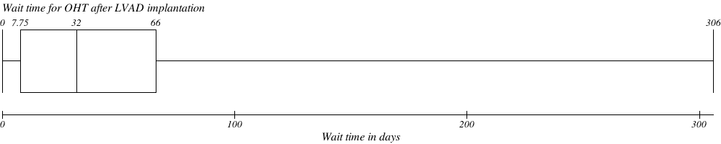

Table 3:

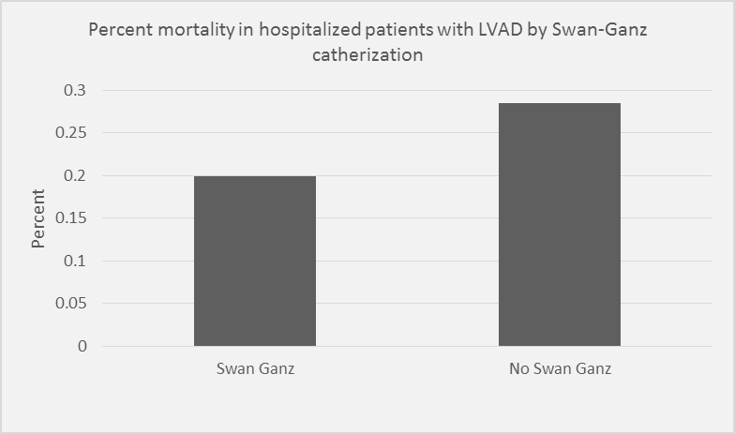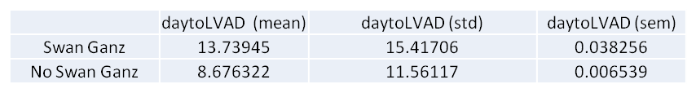

Swan Ganz catheterization *before* LVAD implantation improves mortality

*Patients who received Swan Ganz after LVAD were excluded

Patients with Swan Ganz catheterization wait longer for LVAD implantation than patients without Swan Ganz catheterization

*Patients who received Swan Ganz after LVAD were excluded

